**ePrint Strengths**

Easier to add jobs from the backend

Print management system allows you to save printer setups

Job prioritization

Price estimation and inventory management

You can set add on prices to certain products

Personalized templates for email, job tickets, invoices etc

API integration to Xero

API integration to Mailchimp

Future development included in monthly fee

**ePrint Weaknesses**

More Expensive

Online editor lacks some features

No online templates or images included with the plan

Small company

Can’t request a quote

Online editor doesn’t work on android or iOS devices.

**OnPrintShop Strengths**

Cheaper than ePrint

Online editor allows you to customize a lot of things  
Online editor is easy to use.

Fotolia is integrated with the online editor

Lots of free templates and images provided with plan

Social Media/Facebook integration

Supports PDFlib files (variable text blocks)

Over 500 customers worldwide.

Support is usually 24/7

Quote tracking and approval system

Future development included in monthly fee

**OnPrintShop Weaknesses**

No Job prioritization

Adding jobs from the back end requires you to register an account for new customers

Online editor needs flash to run. Doesn’t support phone/tablet.

Insufficient data in the CSV to create an invoice from

Users can only upload up to 50mb per file

ePrint – needs Microsoft Silverlight to run the online editor. MS Silverlight is not supported on android or iOS devices. Works on Mac though.

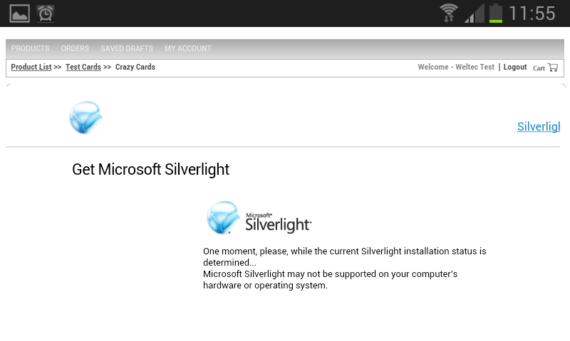

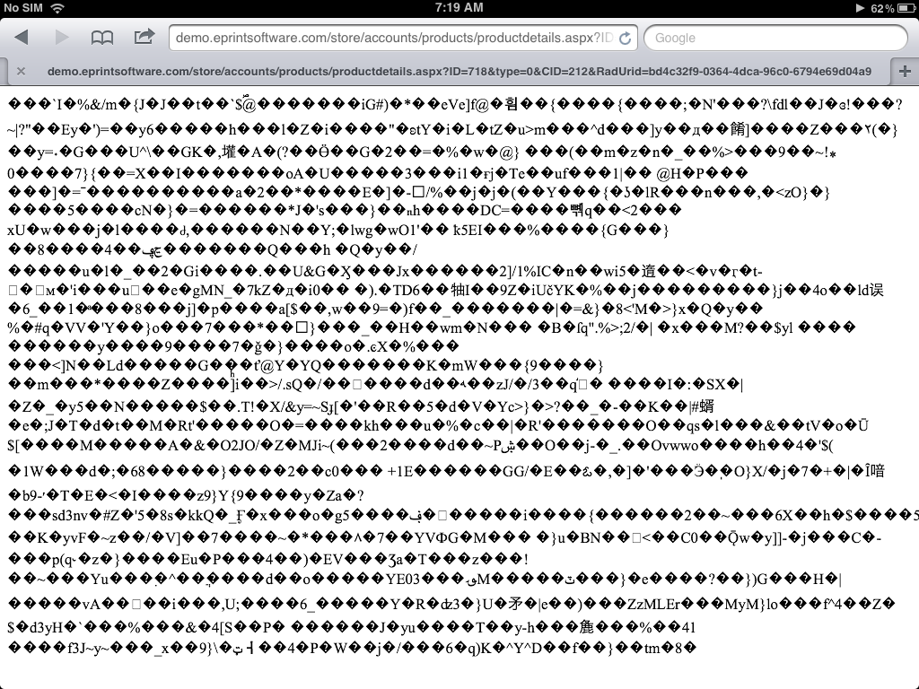

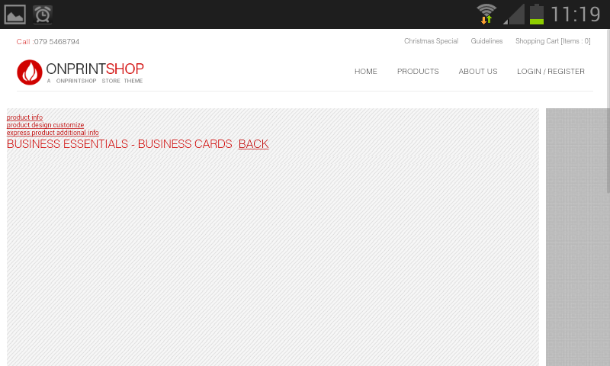

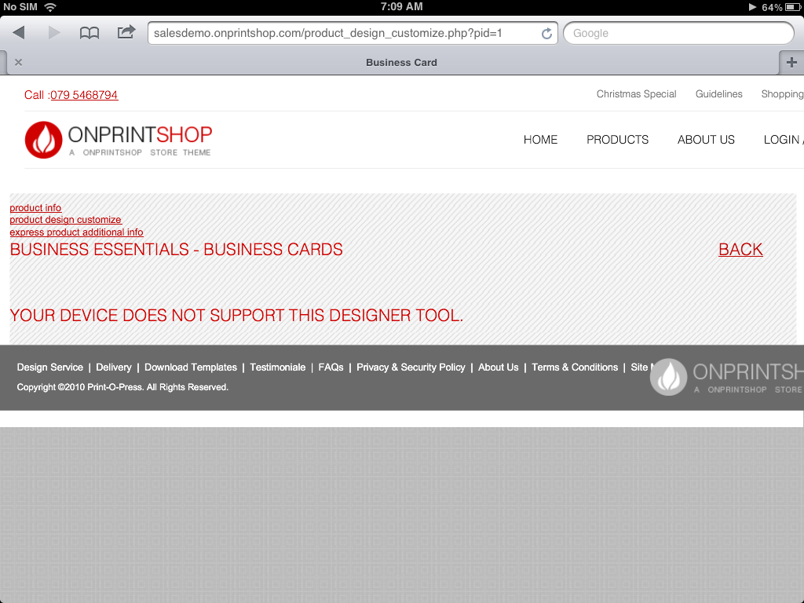

The Online Design Studio doesn’t seem to work on my phone or ipad. I asked a support staff to see if it only works on flash. They said that it opens an HTML version but it doesn’t work when I test it out – could be that it’s not in the demo?

Hello C Reth, my name is Rajan Dave, how may I help you?

**C Reth** 10:51:39 AM

Hi Rajan

**Rajan Dave** 10:52:08 AM

Hi Mr. reth

**C Reth** 10:52:30 AM

I would like to know if the online design studio for OnPrintShop premium plan needs flash player to run. Does it work on android and apple devices?

**Rajan Dave** 10:55:08 AM

It works on flash

**C Reth** 10:55:52 AM

Does it only work on web browsers that have flash player? Because android devices and iphones doesn’t have flash.

**Rajan Dave** 10:59:05 AM

HTML base studio will open in anroid and apple devices

**Rajan Dave** 11:01:08 AM

Is there anything else I can help you with?

**C Reth** 11:01:27 AM

Thats all I wanted to know. Thank you for your time

**Rajan Dave** 11:01:45 AM

Kindly rate this chat so it will help us to improve our service towards our clients.